***PROJECT REPORT***

***ON***

***CAB BOOKING USING MERN***

***A Project Report Submitted in Partial fulfillments of Requirements for the Award of the Degree***

***in***

***Bachelor of technology in***

***Computer science engineering***

***Submitted to***



***Submitted by***

**TEAM ID : LTVIP2024TMID05507**

**TEAM LEAD : Koutarapu Gopichand**

**TEAM MEMBERS: 1)** Annamadevara Siddhardha

**2)Shaik saleem**

**3)Kampasati ashok**

**4) Ganga hema manikantasuryateja**

* **INTRODUCTION**:

Welcome to our cutting-edge cab booking platform, where convenience meets efficiency! Our MERN-based application revolutionizes the way you travel, offering seamless cab booking services at your fingertips.

With our platform, you can easily book a cab anytime, anywhere, with just a few clicks. Whether you're commuting to work, heading to the airport, or exploring a new city, we've got you covered.

Here's what sets us apart:

1. **User-friendly Interface**: Our intuitive interface ensures a hassle-free booking experience for users of all levels.
2. **Real-time Availability**: Check the availability of cabs in real-time, ensuring you always find the perfect ride when you need it.
3. **Secure Payments**: Enjoy peace of mind with our secure payment gateway, allowing you to make transactions seamlessly.
4. **Customizable Options**: Tailor your ride according to your preferences, whether it's selecting a specific vehicle type or choosing additional amenities.
5. **Driver Ratings**: View driver ratings and reviews to ensure a safe and comfortable journey every time.
6. **Track Your Ride**: Track your cab in real-time, so you know exactly when it will arrive at your location.

Our MERN stack-based platform ensures scalability, reliability, and performance, providing you with a seamless booking experience from start to finish.

Experience the future of cab booking with us. Sign up now and let's embark on a journey together!

Feel free to adjust and expand upon this introduction based on your specific application requirements and target audience.

Top of Form

* **LITERATURE SURVEY**:

A literature survey for a cab booking application using the MERN stack would involve researching existing literature, academic papers, articles, and case studies related to various aspects of such applications. Here's a structured approach to conducting a literature survey for cab booking using MERN:

1. **MERN Stack Development**:
   * Explore literature on the MERN stack, which comprises MongoDB, Express.js, React.js, and Node.js.
   * Look for articles, tutorials, and documentation that provide insights into the advantages, best practices, and challenges of using each component in building web applications.
2. **Cab Booking Systems**:
   * Review existing research or case studies on cab booking systems to understand the architecture, functionalities, and user experiences.
   * Analyze how different cab booking platforms handle features such as real-time tracking, payment integration, user authentication, and driver allocation.
3. **User Experience (UX) Design**:
   * Investigate literature on UX design principles and methodologies applicable to cab booking applications.
   * Examine user interface (UI) design patterns, navigation flows, and usability studies to enhance the user experience of the booking process.
4. **Real-time Features and APIs**:
   * Explore literature on real-time web applications and the implementation of features such as real-time tracking of cabs and dynamic updates.
   * Research APIs and frameworks (e.g., Socket.IO) for real-time communication between the client and server in MERN stack applications.
5. **Payment Integration**:
   * Study literature on integrating payment gateways into web applications, focusing on security, compliance, and user experience considerations.
   * Investigate the implementation of payment APIs (e.g., Stripe, PayPal) in MERN stack applications and any associated challenges or best practices.
6. **Mobile App Development**:
   * If applicable, explore literature on building mobile applications using technologies such as React Native for cross-platform compatibility.
   * Analyze case studies or research papers on mobile app performance, user adoption, and maintenance in the context of cab booking services.
7. **Security and Privacy**:
   * Review literature on security best practices for web applications, including authentication, authorization, data encryption, and protection against common vulnerabilities.
   * Investigate privacy concerns related to user data, location tracking, and payment information in cab booking applications.
8. **Performance Optimization**:
   * Examine literature on performance optimization techniques for MERN stack applications, including code splitting, server-side rendering, caching strategies, and database indexing.
   * Look for case studies or performance benchmarks comparing different approaches to scaling and optimizing cab booking platforms.
9. **Case Studies and Industry Trends**:
   * Analyze case studies of existing cab booking platforms built with MERN stack or similar technologies, focusing on their architecture, scalability, and user adoption.
   * Stay updated on industry trends, emerging technologies, and innovations in the field of transportation and mobility services.

By conducting a comprehensive literature survey across these key areas, you can gain valuable insights and guidance for designing, developing, and optimizing a cab booking application using the MERN stack.



* **THEORITICAL ANALYSIS**:
* **Real-Time Features**: MERN stack's combination facilitates the implementation of real-time features like live tracking of cabs, dynamic fare calculation, and instant notifications to users and drivers.
* **Scalability**: With Node.js and MongoDB's scalability features, the application can handle a growing user base and increasing concurrent requests by horizontally scaling the servers and databases.
* **Security**: Implement industry-standard security measures such as HTTPS, encryption for sensitive data, secure authentication mechanisms (e.g., JWT), input validation, and role-based access control to protect user privacy and prevent unauthorized access.
* **Performance Optimization**: Employ performance optimization techniques like code splitting, server-side rendering (SSR), caching, and query optimization to ensure fast load times, smooth user experience, and efficient use of server resources.
* **Cross-Platform Compatibility**: Utilize React Native for mobile app development to ensure cross-platform compatibility, enabling users to book cabs conveniently from both web and mobile devices.
* **Third-Party Integrations**: Integrate third-party services like payment gateways (e.g., Stripe, PayPal), mapping APIs (e.g., Google Maps), and SMS gateways for OTP verification and notifications to enhance the application's functionality and user experience.

By leveraging the strengths of the MERN stack and incorporating theoretical principles and best practices, a cab booking application can be developed to deliver a seamless, secure, and scalable solution for users and service providers alike.

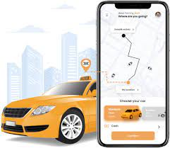

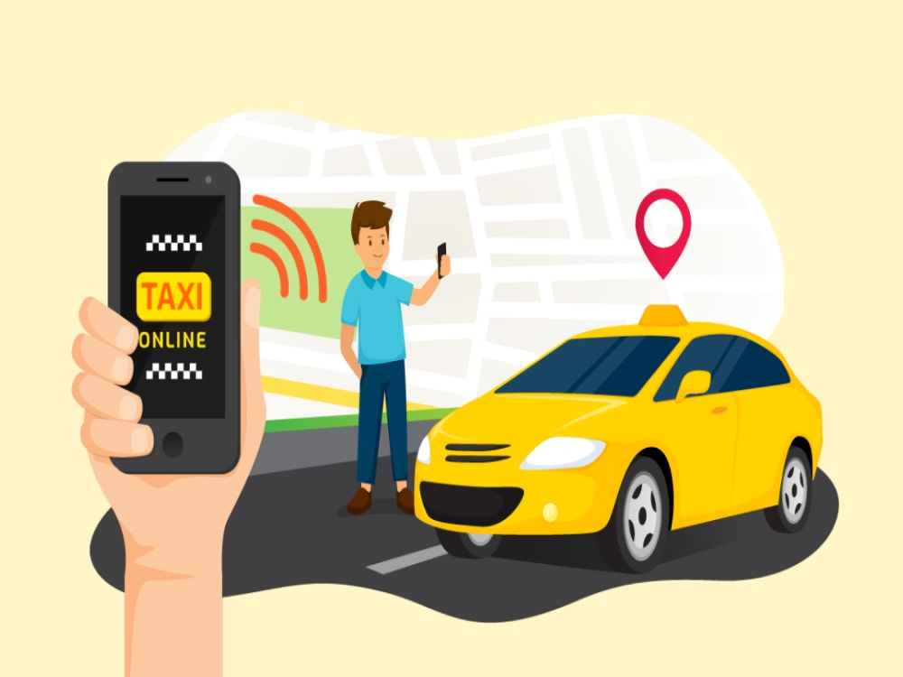

* **RESULT:**

To implement cab booking functionality using the MERN (MongoDB, Express.js, React.js, Node.js) stack, you'd typically follow these steps:

1. **Database Setup (MongoDB)**:
   * Design the database schema to store user information, cab details, booking information, etc.
   * Set up MongoDB either locally or through a cloud service like MongoDB Atlas.
2. **Backend Development (Node.js with Express.js)**:
   * Create APIs for user authentication, cab availability, booking creation, etc.
   * Implement CRUD operations for managing users, cabs, and bookings.
   * Integrate with MongoDB using an ORM like Mongoose.
   * Implement validation and error handling for API requests.
3. **Frontend Development (React.js)**:
   * Design UI components for user registration, login, cab selection, booking form, etc.
   * Use React Router for navigation between different pages.
   * Implement forms for user input and validation.
   * Make API requests to the backend for fetching cab details, making bookings, etc.
4. **Authentication**:
   * Implement user authentication using JWT (JSON Web Tokens) or sessions.
   * Secure routes that require authentication to access.
5. **Real-time Updates**:
   * Use technologies like WebSockets (e.g., Socket.io) for real-time updates on cab availability, booking status, etc.
6. **Testing**:
   * Write unit tests for backend APIs and frontend components.
   * Perform integration testing to ensure different parts of the application work together seamlessly.
7. **Deployment**:
   * Deploy the backend and frontend to a hosting service like Heroku, AWS, or DigitalOcean.
   * Set up CI/CD pipelines for automated deployment.
8. **Monitoring and Maintenance**:
   * Implement logging and monitoring to track application performance and detect errors.
   * Regularly update dependencies and fix security vulnerabilities.

Here's a basic example of what the code might look like for a simple cab booking application:

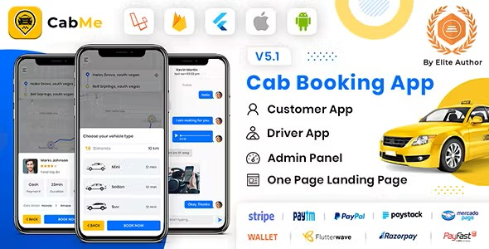



* **ADVANTAGES**:

Using the MERN stack for cab booking applications offers several advantages:

1. **Full Stack Development**: MERN encompasses frontend (React.js), backend (Node.js with Express.js), and database (MongoDB) technologies, allowing developers to build the entire application using a unified JavaScript-based stack. This streamlines development and maintenance since developers can work on both frontend and backend aspects of the application using the same language and tools.
2. **Real-time Updates**: With technologies like WebSockets (e.g., Socket.io), you can implement real-time updates for cab availability, booking status, and notifications. This enhances the user experience by providing timely information and feedback.
3. **Scalability**: Node.js, with its event-driven architecture, is well-suited for handling concurrent requests, making it scalable for applications with varying traffic loads. MongoDB's flexible schema and horizontal scalability options (sharding) enable handling large volumes of data efficiently.
4. **Flexibility and Agility**: MERN stack allows for rapid prototyping and iterative development due to its component-based architecture, rich ecosystem of libraries and frameworks, and support for agile methodologies. This is particularly advantageous in dynamic markets like transportation, where quick adaptation to changing requirements is crucial.
5. **Cross-platform Compatibility**: React.js supports building cross-platform applications, enabling the development of cab booking apps that work seamlessly on web browsers, mobile devices (using frameworks like React Native), and even desktop platforms (using Electron).
6. **Rich User Interface**: React.js provides a declarative and component-based approach to building user interfaces, facilitating the creation of interactive and responsive UIs for cab booking apps. This improves user engagement and satisfaction.
7. **Community Support and Resources**: The MERN stack has a large and active community of developers, which means extensive documentation, tutorials, and third-party libraries are available to aid development. This can accelerate development and troubleshooting processes.
8. **Cost-effective Development**: Many tools and libraries in the MERN ecosystem are open-source and free to use, reducing development costs. Additionally, using JavaScript across the entire stack can lead to more efficient development cycles and reduced time-to-market.
9. **Security**: While security is a concern in any application, the MERN stack provides several tools and best practices for implementing security measures. For example, you can use JWT (JSON Web Tokens) for authentication, implement HTTPS for secure communication, and follow OWASP guidelines for securing web applications.
10. **Integration Capabilities**: Node.js facilitates easy integration with third-party services and APIs, allowing cab booking apps to leverage features such as payment gateways, mapping services, and social media platforms to enhance functionality and user experience.

Overall, the MERN stack offers a powerful and versatile toolkit for developing cab booking applications that are scalable, efficient, and feature-rich.

* **DISADVANTAGES**:

While the MERN stack offers many advantages for building cab booking applications, there are also some potential disadvantages to consider:

1. **Learning Curve**: Learning and mastering all components of the MERN stack (MongoDB, Express.js, React.js, Node.js) can be challenging, especially for developers who are new to JavaScript or web development. This can lead to longer development times and increased complexity, particularly for inexperienced teams.
2. **Performance**: While Node.js is known for its scalability and non-blocking I/O model, it may not be the best choice for CPU-intensive tasks or applications with high computational requirements. Additionally, MongoDB's document-based storage model may not be optimal for all use cases, leading to potential performance bottlenecks, especially with complex queries or large datasets.
3. **Single Language Dependency**: While using JavaScript throughout the entire stack can be advantageous in terms of code reuse and developer productivity, it also means that developers are limited to using a single language. This can be a disadvantage if certain components of the application would benefit from using a different language or technology.
4. **Security Concerns**: Building secure applications with the MERN stack requires careful attention to security best practices, such as input validation, authentication, authorization, and protection against common web vulnerabilities (e.g., XSS, CSRF). Node.js, in particular, may be more susceptible to certain types of attacks if not properly secured.
5. **Scalability Challenges**: While Node.js is designed to be highly scalable and performant, scaling MERN applications horizontally can be challenging, especially when dealing with stateful components or shared resources. Additionally, MongoDB's lack of support for transactions in distributed environments may complicate scaling efforts for applications with complex data requirements.
6. **Community and Ecosystem Fragmentation**: While the MERN stack has a large and active community, the ecosystem can be fragmented, with multiple competing libraries, frameworks, and tools for accomplishing similar tasks. This can lead to decision paralysis and increased overhead in terms of evaluating and integrating third-party dependencies.
7. **Deployment Complexity**: Deploying MERN applications can be more complex compared to traditional monolithic applications, especially when dealing with microservices architectures or containerized deployments. Managing dependencies, environment configurations, and deployment pipelines across multiple components can introduce additional overhead and complexity.
8. **Tooling and Debugging**: While the MERN stack offers a rich ecosystem of tools and libraries, managing dependencies and debugging issues across multiple layers of the stack can be challenging, especially for large-scale applications. Ensuring compatibility and consistency between different versions of libraries and frameworks can require careful coordination and testing.
9. **SEO Limitations**: While React.js offers excellent performance and interactivity for client-side rendering, it may not be as SEO-friendly out of the box compared to server-side rendering solutions. This can impact search engine visibility and discoverability for cab booking applications, especially for content-heavy pages or dynamic content.
10. **Vendor Lock-in**: While MongoDB, Express.js, React.js, and Node.js are all open-source technologies, relying heavily on specific components of the MERN stack can lead to vendor lock-in. Switching to alternative technologies or platforms may require significant effort and resources, especially for applications with complex dependencies or tight coupling between components.

Top of Form

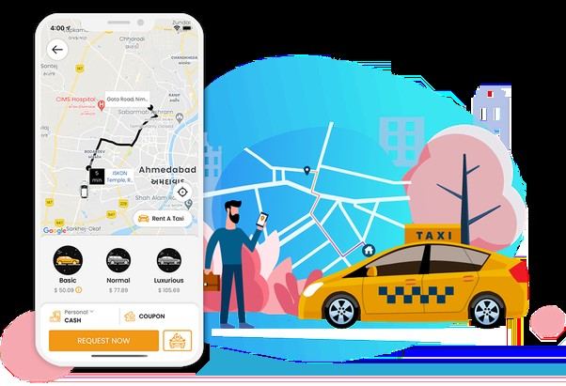

Top of Form

* APPLICATIONS:

There are numerous applications for cab booking systems built using the MERN stack, catering to various needs and markets. Here are some examples:

1. **Ride-hailing Services**: These are perhaps the most common applications for cab booking systems. Users can book a ride through a mobile or web app, specifying their pickup and drop-off locations, and choose from available cab options. Examples include Uber, Lyft, and Ola.
2. **Corporate Shuttle Services**: Companies often provide shuttle services for employees to commute between office locations, public transportation hubs, or residential areas. A MERN-based cab booking system can streamline the booking process for employees and manage scheduling, billing, and reporting for the company.
3. **Tourism and Travel Agencies**: Travel agencies and tour operators can use a MERN stack cab booking system to arrange transportation for tourists, whether it's airport transfers, city tours, or intercity travel. The system can integrate with the agency's website or mobile app to offer convenient booking options for customers.
4. **Hotel and Hospitality Services**: Hotels and resorts frequently offer transportation services for guests, such as airport pickups, sightseeing tours, or shuttle services to nearby attractions. A MERN-based cab booking system can help hotels manage these services efficiently and provide guests with a seamless booking experience.
5. **Event Management**: Event organizers often need transportation services for attendees, speakers, and staff. A MERN stack cab booking system can handle logistics such as coordinating pickups, managing multiple routes, and ensuring timely arrivals for events of all sizes.
6. **Medical Transportation Services**: Healthcare facilities, rehabilitation centers, and elderly care homes may require transportation services for patients who need to visit clinics, hospitals, or therapy sessions. A MERN-based cab booking system can facilitate scheduling and coordination for medical transportation, ensuring patients receive timely and reliable service.
7. **University and Campus Transport**: Universities and colleges often operate shuttle services for students, faculty, and staff to navigate large campuses or connect with public transportation networks. A MERN stack cab booking system can optimize routes, manage schedules, and provide real-time tracking for campus shuttles.
8. **Courier and Delivery Services**: While not strictly for passengers, courier and delivery companies can benefit from a MERN-based cab booking system to manage pickups, deliveries, and route optimization. The system can handle package tracking, driver assignments, and customer notifications for delivery services.
9. **Specialized Transport Services**: There are niche markets for specialized transportation services, such as wheelchair-accessible cabs, pet-friendly rides, or luxury car rentals. A MERN stack cab booking system can cater to these specific needs and provide customized booking options for different user demographics.
10. **On-Demand Services**: Beyond traditional cab booking, MERN stack applications can support various on-demand services, such as food delivery, grocery delivery, or parcel pickup and delivery. These applications use similar booking and dispatching mechanisms but focus on different types of services.

These are just a few examples of the diverse applications for cab booking systems built using the MERN stack. The flexibility and scalability of the MERN stack make it suitable for a wide range of transportation and logistics scenarios, catering to both businesses and individual users.

* CONCLUSION:

In conclusion, building a cab booking application using the MERN (MongoDB, Express.js, React.js, Node.js) stack offers numerous advantages and opens up a wide range of applications across various industries. By leveraging the capabilities of each component in the stack, developers can create robust, scalable, and feature-rich solutions that cater to the needs of both businesses and individual users.

The MERN stack's full-stack development approach streamlines the development process, allowing developers to work seamlessly across frontend and backend components using a unified JavaScript-based framework. This not only enhances developer productivity but also facilitates rapid prototyping and iterative development, crucial in dynamic markets such as transportation and logistics.

Furthermore, the MERN stack provides powerful tools and libraries for building real-time applications, ensuring timely updates on cab availability, booking status, and notifications. This enhances the user experience by providing immediate feedback and increasing overall efficiency.

However, it's important to acknowledge some potential challenges, such as the learning curve associated with mastering all components of the MERN stack, performance considerations, security concerns, and deployment complexities. Addressing these challenges requires careful planning, adherence to best practices, and continuous monitoring and optimization throughout the development lifecycle.

Overall, the MERN stack offers a versatile and scalable framework for building cab booking applications tailored to various industries and use cases. With its rich ecosystem of libraries, active community support, and flexibility, the MERN stack remains a popular choice for developers looking to create innovative and user-friendly solutions in the transportation and logistics domain.

Top of Form